GCIS123 – Assignment 1 – Joel, Clevin, Sai
Screenshots
Sample input:
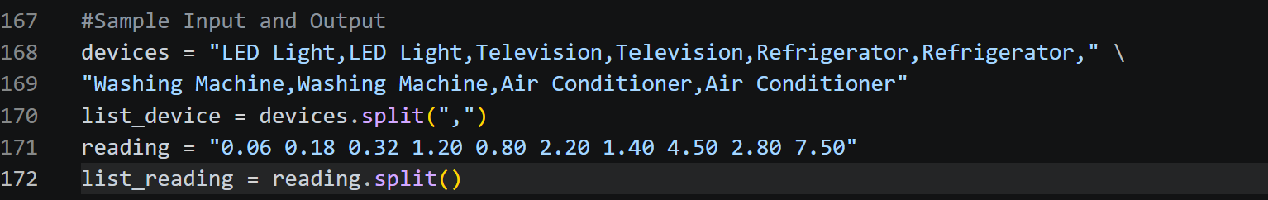

Output:
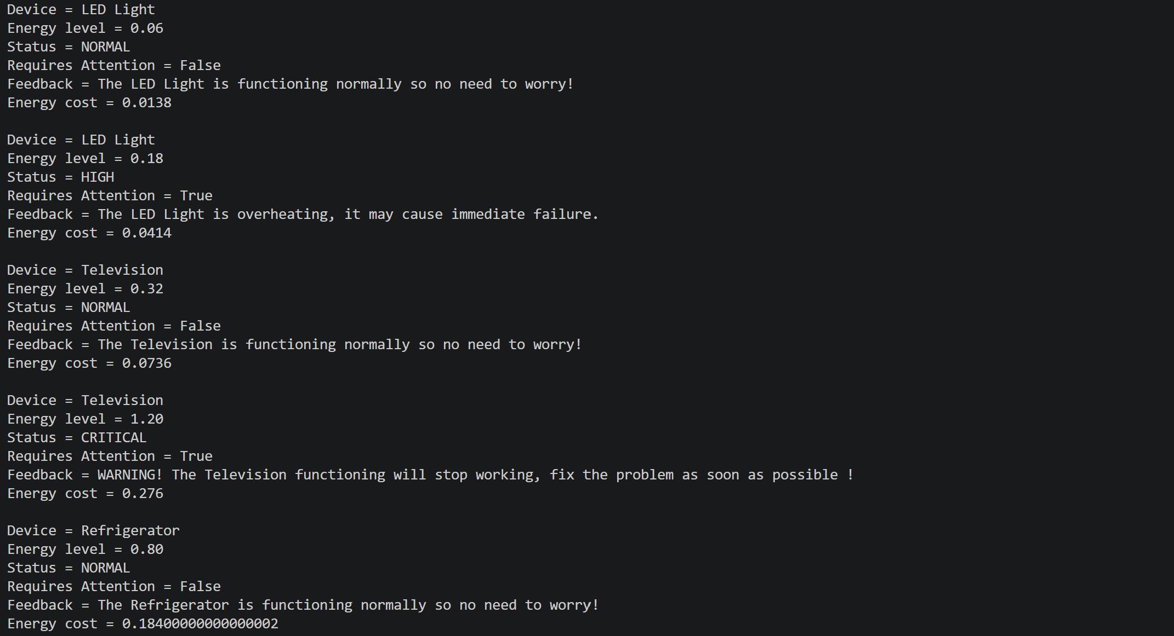
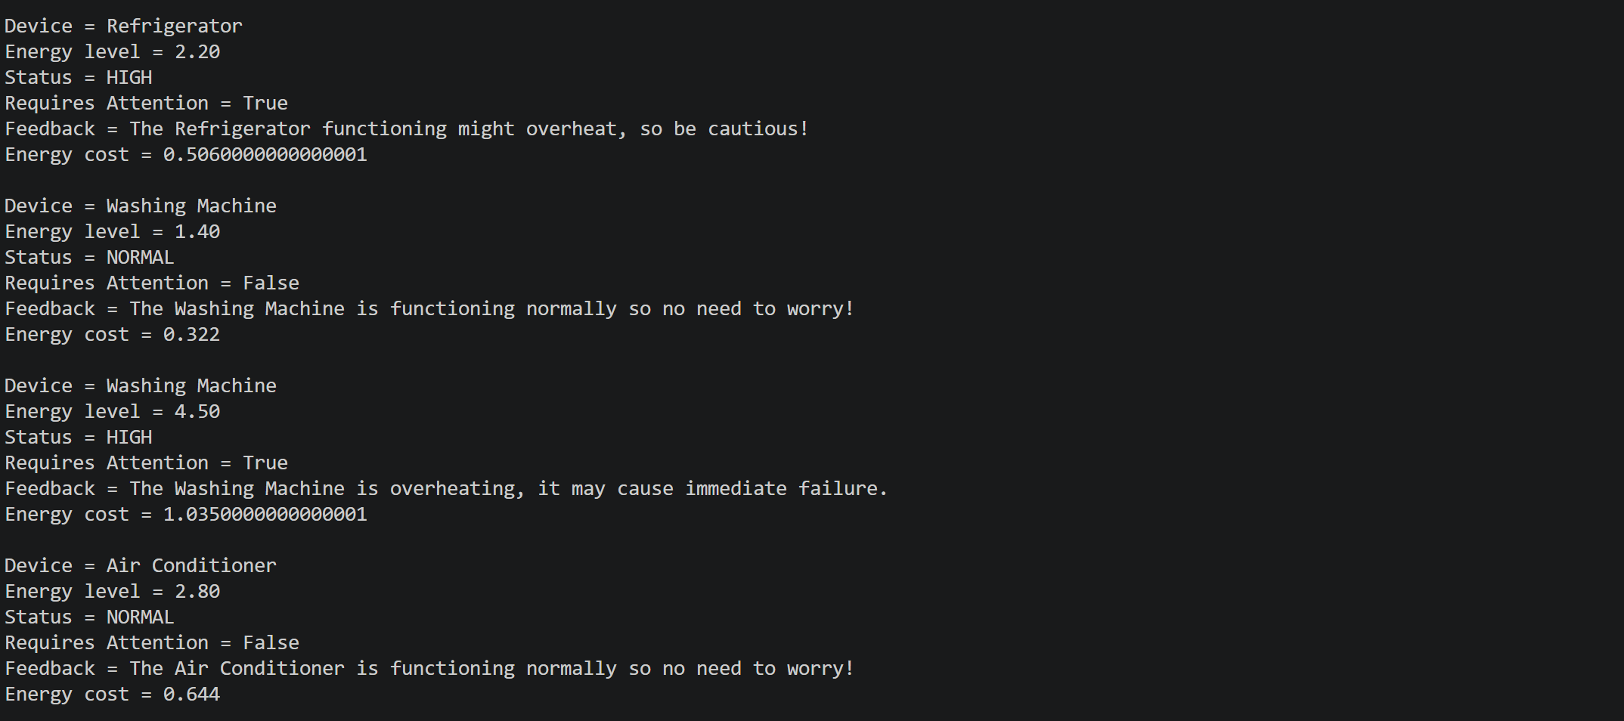
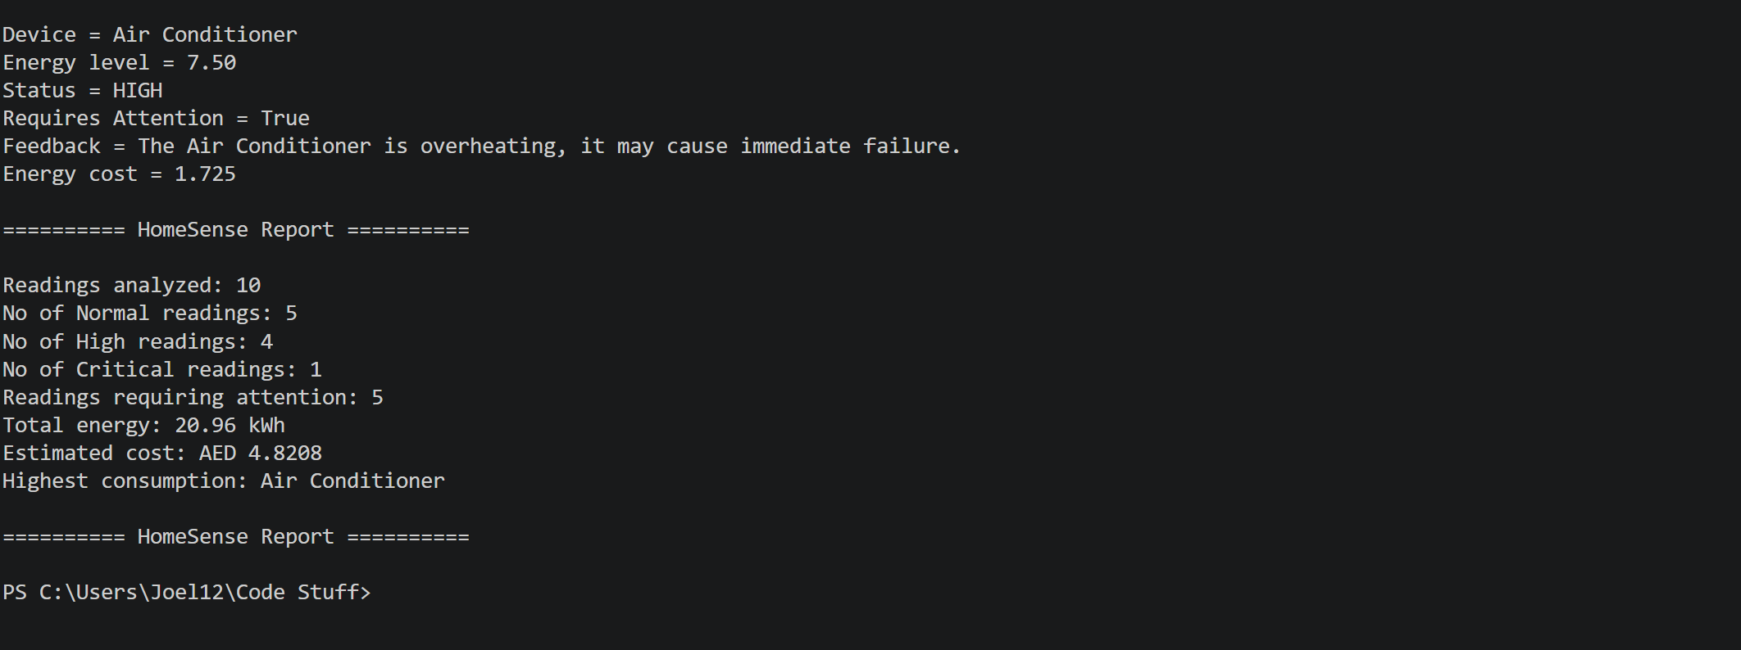

Pytest successful tests:
